Glydea™ ULTRA

Somfy's curtain motorisation solutions are made to meet the requirements of the most prestigious projects from luxury apartments to high quality hotels and meeting conference venues. With Somfy's focus on Design for Silence, curtain motors are packed with innovative features that provide an acoustic performance, making it one of the quietest motorisation solutions on the market. This exceptional achievement absorbs the noise and vibration within the motor and across the entire system to decrease silence for peace of mind, wellbeing and everyday comfort within the residential homes and commercial buildings. Somfy has a new market standard for ultra-quiet performance. They also offer discreet, flexible and robust solutions to serve your imagination and broaden your horizons.

Benefits of Glydea™ULTRA

The Glydea ULTRA is discreet and offers light, fluid movement with a strong lifting capacity of up to 60kg. Somfy's commitment to performance and strength makes this innovation possible. Glydea ULTRA is suitable for every project, all decors and in any place where silence offers wellbeing. It is compatible with multiple technologies (WT/DCT/RTS/RS485 through a module) to suit user control preferences and is also connected to meet the needs of smart buildings and homes. Users can enjoy their smart home by controlling curtains with Connexoon Window RTS and voice control (through IFTTT).

Key Features
- Touch Motion feature which is perfect for every situation
- Maximise energy efficiency by integrating Somfy sensors and controls for a fully automated solution
- Extends the lifespan of your curtains while avoiding the damage caused by cords and manual operation
- Provides the level of comfort and reliability expected in luxury locations
- Improves the image of a venue with elegance and makes the job of service personnel easier

GlydeaTM ULTRA is reliable, adaptable, robust and discreet; the premium solution for residential and commercial projects.

Glydea Sophistication
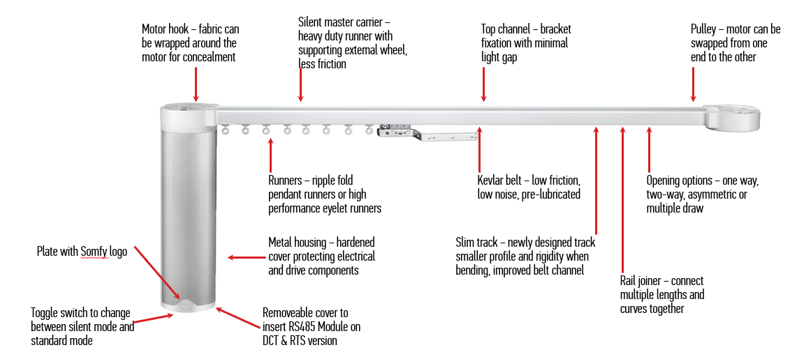

Aesthetic
- Somfy Innovation: patented cover and sleek design hides the cabling and protects the connectors and the control modules inside the motor
- Reduces light gap thanks to the rail design and the swivel ceiling bracket
- Adjustable limits, to allow the curtain to fall perfectly

Flexibility
- Large offer of hardware: components to adapt to different types of curtains
- Somfy innovation: plug-in modules for a large range of control systems

Quiet
- Low noise level from its motorised track thanks to the motor design and the use of a timing belt
- Soft start and soft stop

Efficiency
- Touch Motion feature, to open and close the curtain simply by pulling on thefabric
- "My" function, to automatically move the curtain to a preferred position
- Adjustable speed: 12.5cm/s to 20cm/s

Robust Design
- Somfy innovation: Lyrease mechanical system which automatically disengages the motor drive shaft for manual operation preserving the fabric
- Setting buttons and cabling not accessible to the end user
- No maintenance necessary after installation

